WEEK 6 DAY 1 AND 2
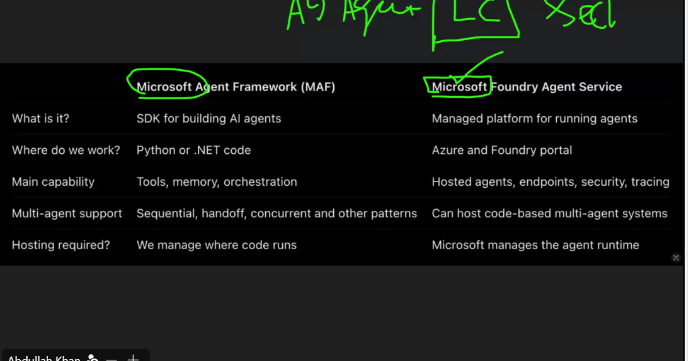
Foundry-eg micrososft foundry, fully cloud driven ecosystem
Framework-build it yourself, kind of copy of langchain, heavily .net driven (on production systems), code driven ecosystem, eg-microsoft agent framework (maf)
Point of contact, sort of security provided -why Microsoft is preferred
Orchestration-the stitching of apps
Why to know langchain, langgraph, framework, foundry etc- diff projects shave diff budgets
Rich projects- use ms ecosystem
Deficient budget-langchain etc
Azure portal
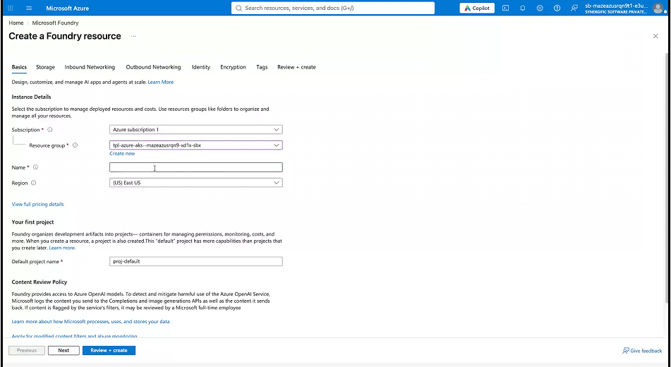
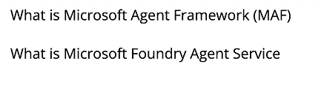
research doc uploaded separately
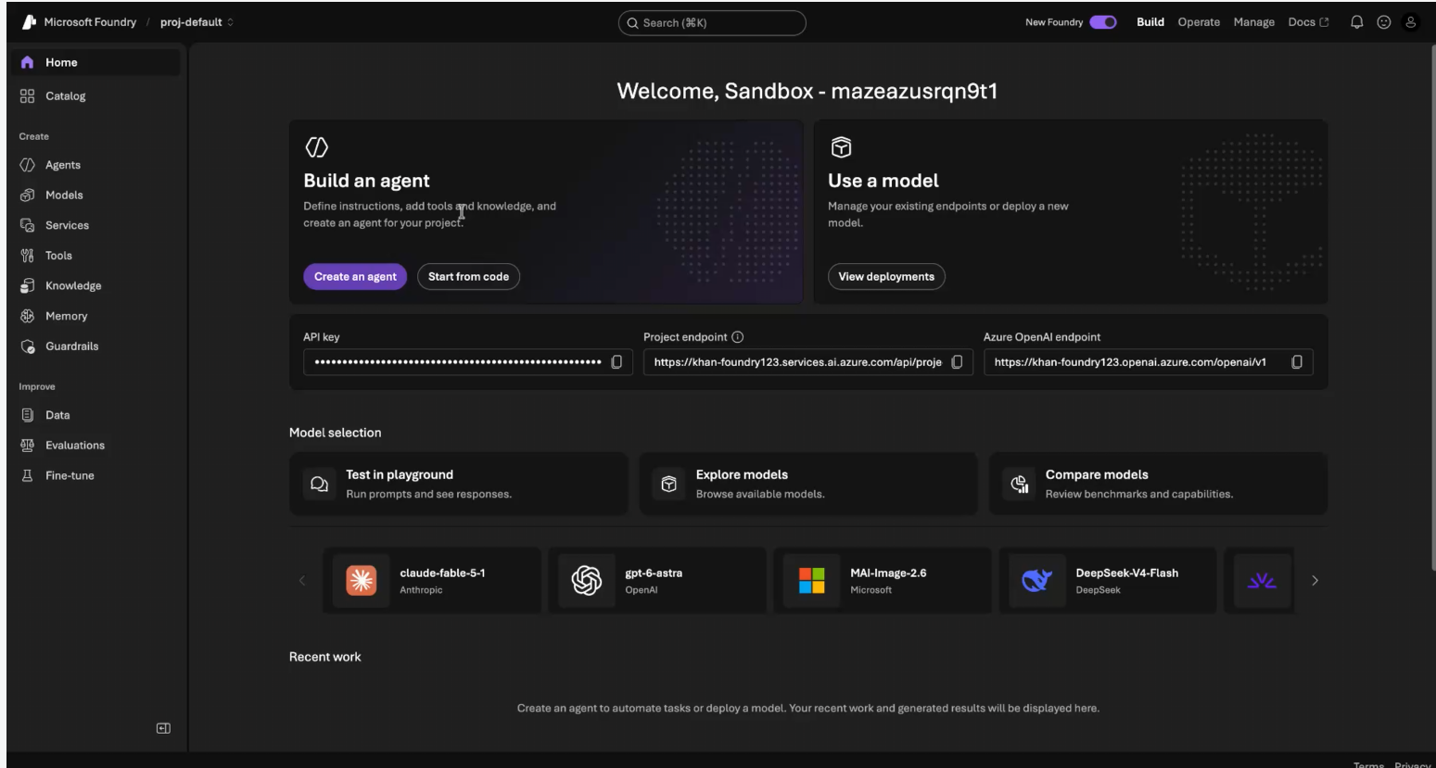
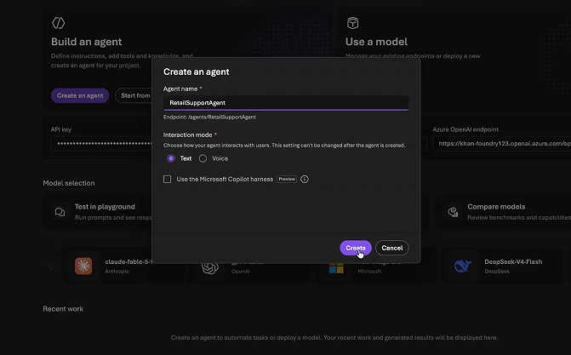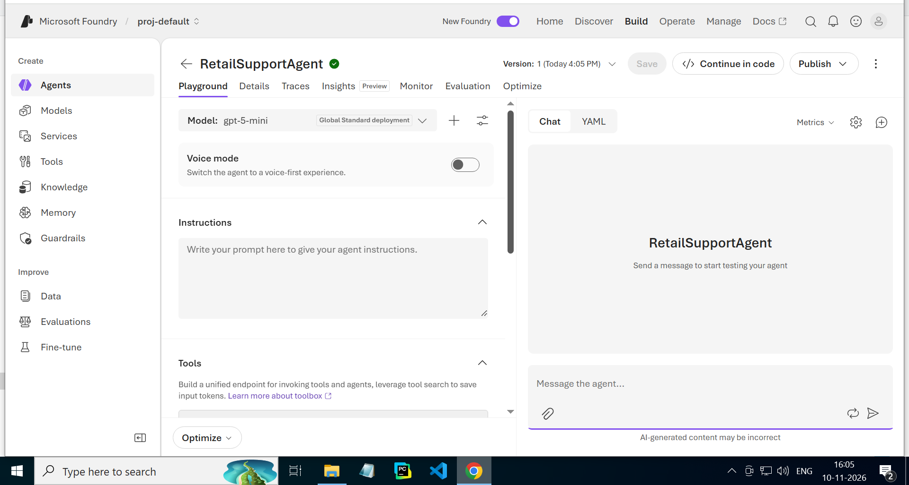

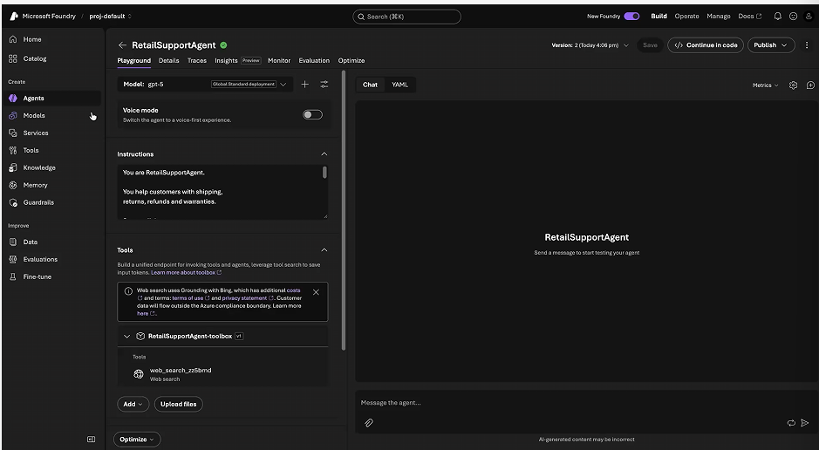
https://codeshare.io/5Dd3Rl
instructions :
You are RetailSupportAgent.

You help customers with shipping,
returns, refunds and warranties.

Store policies:
- Standard delivery: 3-5 business days.
- Express delivery: 1-2 business days.
- Returns allowed within 7 days.
- Refunds processed within 5 business days.
- Electronics warranty: 12 months.

Rules:
- Answer only customer support questions.
- Never invent order details.
- Do not claim to process actual refunds.
- Keep responses short and clear.
DEFAULT -GPT 5
TESTING:
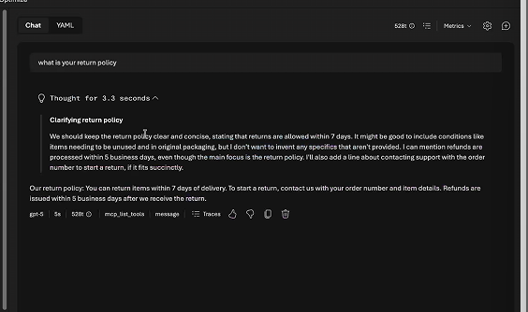
UPLOAD FILES-
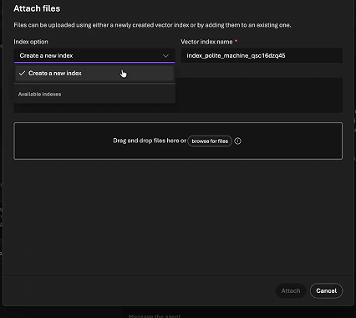
CREATE INDEX ON A PARTICULAR COLUMN/VALUE
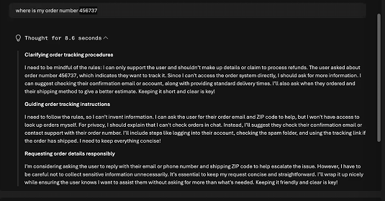
WILL NOT MAKE UP FALSE INFO
UPLOADING store_policy.txt:
It created a couple of indexes
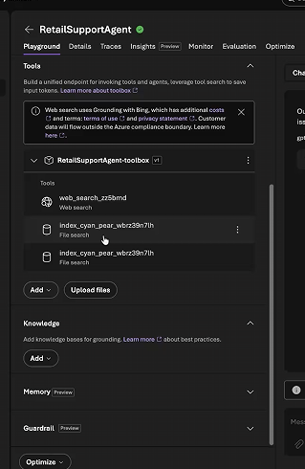
Update the instructions :
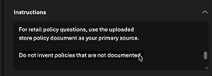
Asking a policy related question-
Before doing that remove one index and give a unique name
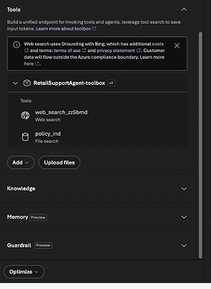
ARE THE GIFTCARDS REFUNDABLE?
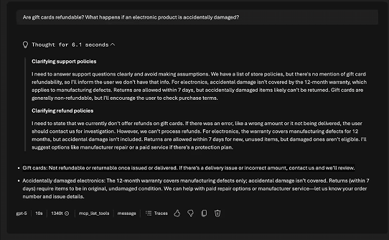
https://codeshare.io/5Dd3Rl
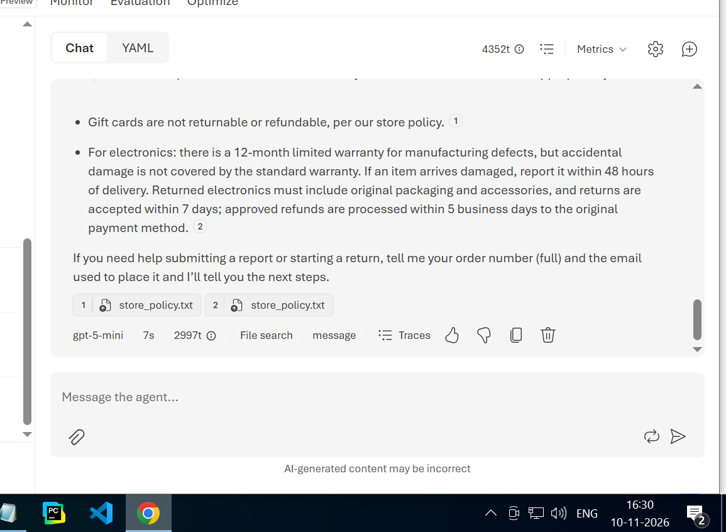
Look at details like traces, insights,
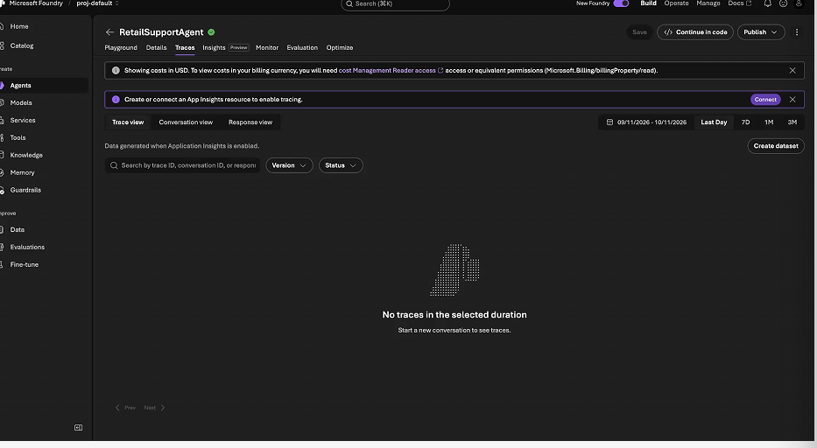
Inspecting trace id:
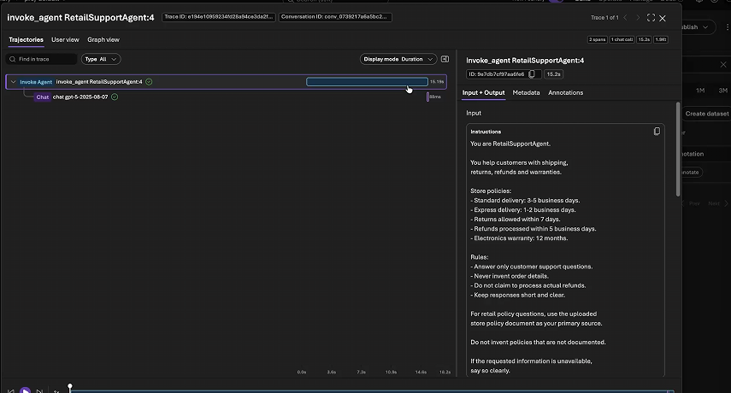
Optimize tab-
Explore catalog
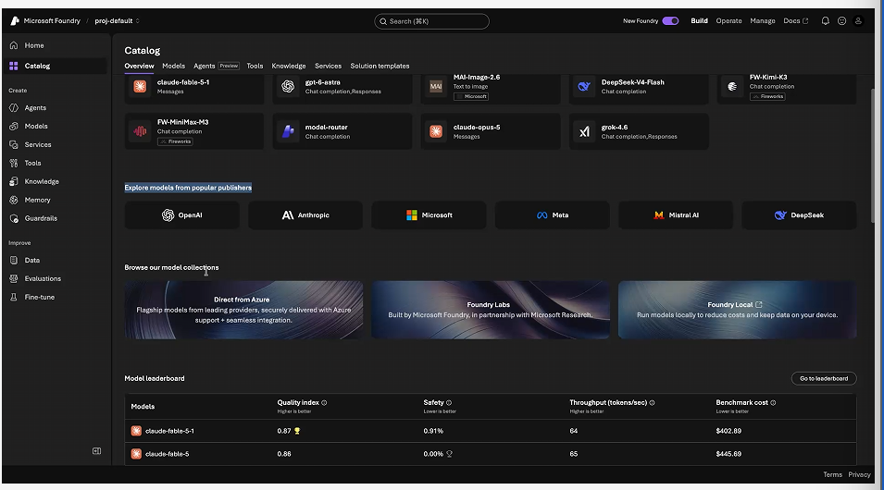
Claude, fable usually on top
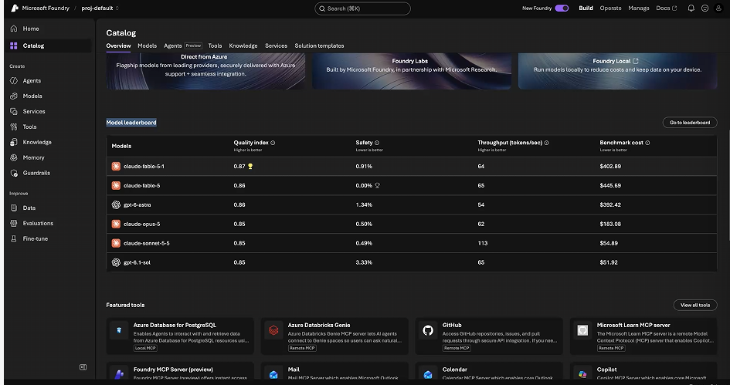
Safety is astra is bad??
“view all tools”
Tools to attach to your model
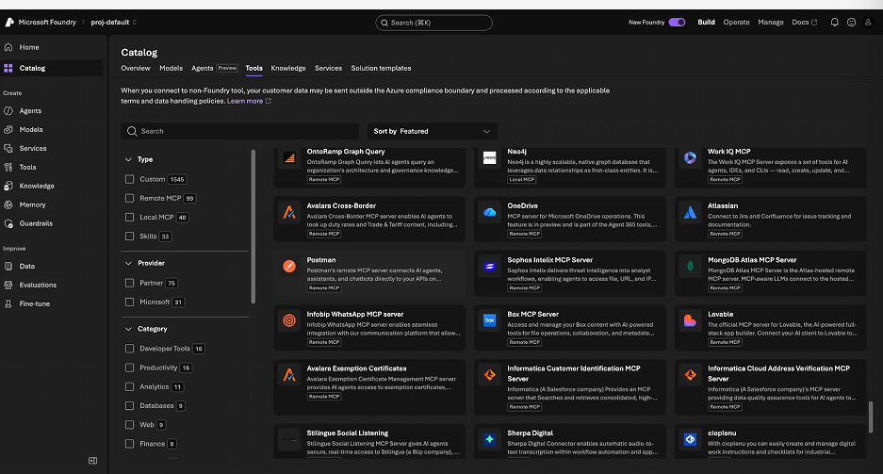
Can also finetune models


